Proxima Centaury b‘s habitability zone

This project aims to find an area suitable for human habitation on the planet Proxima Centauri b.
Using ArcgisPro and Jupiter Notebook, we are asked to perform a geospatial analysis of the data and to produce a map showing an area representing a target.
The subject I chose for this project is the habitable zone of a planet outside the solar system. The analysis of planets inside the solar system are numerous. I wanted to realize this analysis on a more distant planet, less known. My choice of Proxima of the Centaur b seemed interesting for several reasons:
- First of all it is a planet that has a potential to be habitable. This planet has a good point in common with the Earth. It is in the habitable zone of its stars. It is possible that there is liquid water as well as an atmosphere similar to Earth even if this remains only suppositions.
- It is also the closest exoplanet to us. Only 4.37 light years from the Sun. This makes it a perfect candidate even if it would take us several thousand years to get there.
- Data for this planet exist. Although these are only simulations, NASA has a lot of data on this exoplanet which allows us to analyze it.
The zone defined as habitable represents a part of the planet where several conditions are favorable for humans to thrive. The conditions will not be similar to those of the Earth but rather sufficient to live there.
First of all, it is necessary to make choices about certain parameters of the planet in order to study it: we consider that Proxima has an atmosphere similar to ours and then that the planet makes 3 rotations on itself for each revolution around its star. These choices are important because the simulations performed require these parameters.
Now that we have set the basic conditions, we can perform the analysis. This one will take place in several steps. We must select the parameters with which the analysis will be performed. Then create a map for each parameter. Finally, combine all these maps into one map which will be the final map of the project.
The selected data are :
- Temperature. This is obviously the most important parameter because if the temperature is too high, the water will be in gaseous form and it will be impossible to live in. With a too low temperature our organisms would not survive and it would be impossible to grow anything.
- Precipitation. Very important because if there is water on the spot it will be important to place somewhere where the precipitation will not be zero or it will be impossible to grow fruits and vegetables and pastures. Also, too much precipitation can cause problems and especially reveal frequent storms.
- Sunshine. This ensures that plants can photosynthesize. Natural light is also beneficial for the human body, both physically and psychologically. Also, as it was complicated to obtain data on the radiations, the sunshine is in fact linked to it as we consider a similar atmosphere. It is thus necessary to have a sufficient sunshine but not intensive under penalty of undergoing intense radiations.
Now that the parameters have been selected, the Flowchart must be created to explain the method.

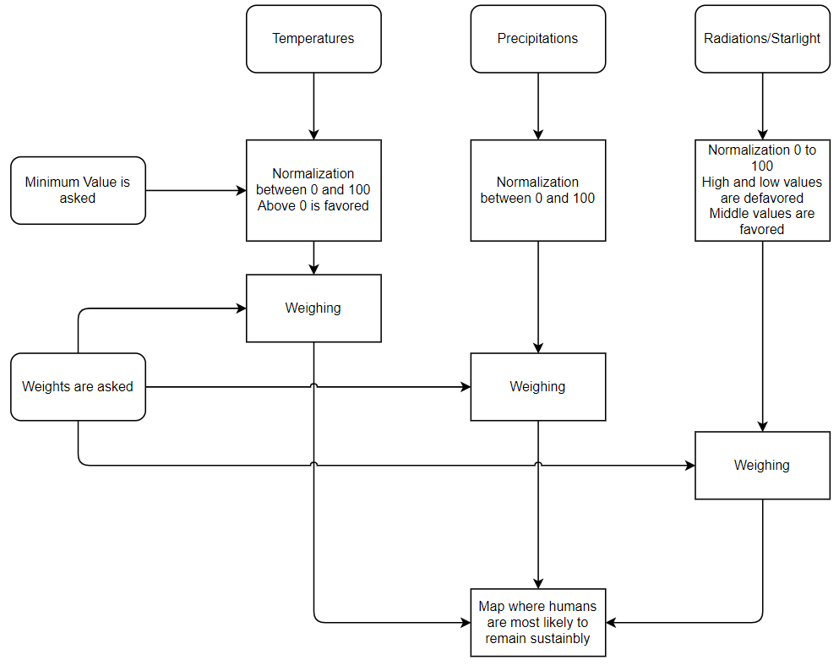
Figure 1 Flowchart

The selected data are entered at the top. For the temperature, the values must first be normalized between 0 and 100 with the minimum value which is an input requested from the user. Values above 0 will be favored. For precipitation, the values must also be normalized between 0 and 100. For the sunshine, the same thing with the difference that the low and high values will both be disadvantaged in favor of intermediate values.
The 3 data will be assigned a coefficient. These coefficients are requested from the user and strongly influence the result. After applying the coefficients, the map that emerges is the one where humans have the best chance to survive and prosper.
For the implementation, I used the Python language on Jupiter Notebook.
To implement the precipitation, I just had to integrate the .cdf data in ArcgisPro and then create a layer. By choosing the right color here is the result.

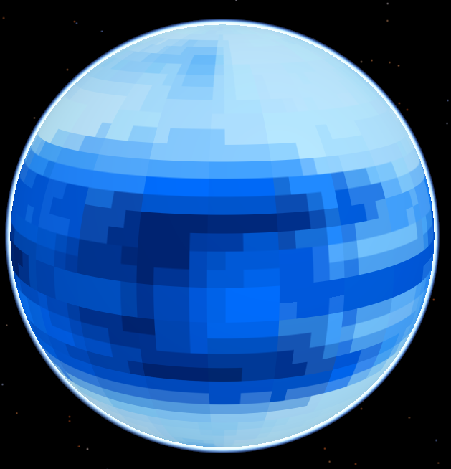
Figure 2 Precipitations
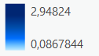
Figure 3 Interval before normalization
What we can notice is that precipitation is mostly concentrated on a wide band around the equator of the planet. The ideal place is therefore in this periphery. On the other hand, the two poles of the planet are free of it.
To normalize the values we perform a calculation on each cell of the raster. We use a simple formula where we subtract the minimum value to the value of the cell and then we divide the whole by the maximum value minus the minimum value. Finally, we multiply the whole by 100 and we obtain a range of continuous values from 0 to 100.

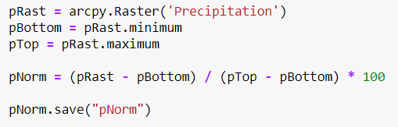
Figure 4 Code for the standardization of precipitation
Here is the code in Python to normalize the precipitation. We select the layer Precipitation and we get the value of the cells. We also take the maximum and minimum value of the range. We perform the calculation and then we save everything in a new layer pNorm.
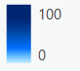
Figure 5 Interval after normalization
To implement the temperatures, the same procedure as above must be followed. Only, there is a notable difference with the temperatures. Values above 0 should be greatly favored.
To do this we will have to split our range of values into two, apply coefficients and then put them together.
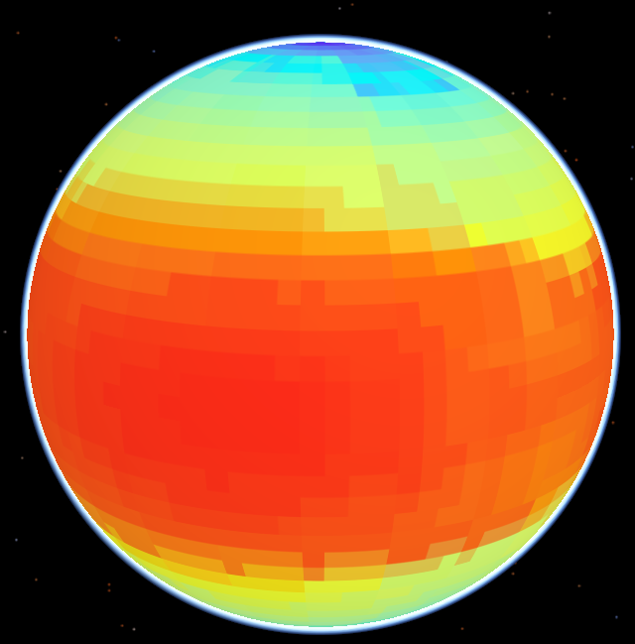
Figure 6 Temperatures map before normalization
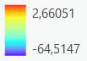
Figure 7 Interval before normalization
Given that at atmospheric pressure, water is liquid above 0 degrees Celsius, it is necessary to favor these values because they would allow humans to live much better. It should be noted that the temperatures of this planet reach -64 in places up to 2.8 degrees Celsius which is rather close to the Earth.
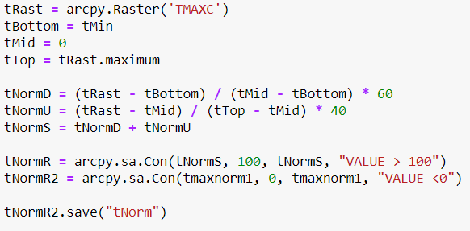
Figure 8 Temperature implementation code
As for the precipitation, we get the values of each cell. We then obtain the minimum value and 0 which will be the limits of the first interval. The minimum value indicated by the user and 0 will form the limits of the second interval. We apply a coefficient of 40 for the first interval and 60 for the second which means that the values between Min and 0 will represent 60% of the final interval and that the values between 0 and Max will represent 40% of it.
Don't forget to crop the values greater than 100 and less than 0 and you get this interval.

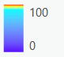
Figure 9 Interval after normalization
Using myself a minimum of -20C° we obtain this map of the planet.
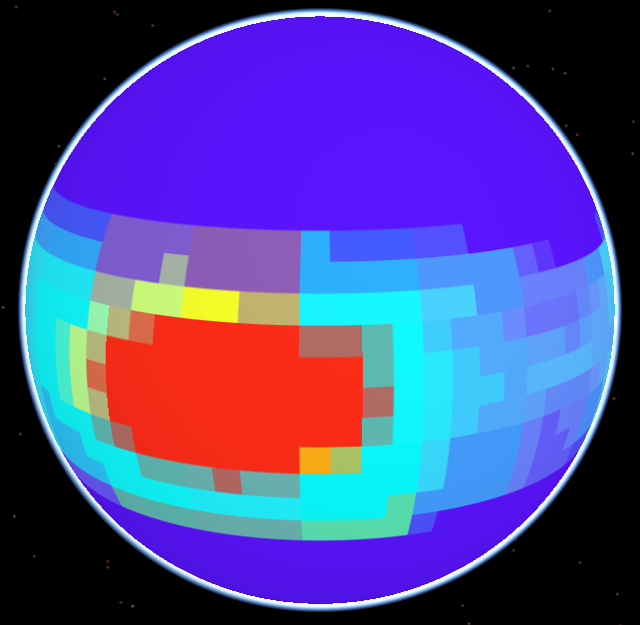
Figure 10 Temperature map after normalization (minimum -20)
The minimum being -20 we see that the colors around the poles are indistinguishable because they are all below this minimum. We can also see that the values higher than 0 have a very important value and a very red color which makes it easy to distinguish them.
For the implementation of the sunshine, we had to do even more. It is necessary that the high and low values are both disadvantaged in favor of the intermediate values. For this purpose, we have to separate the starting interval into 3 parts: the low value interval, the intermediate interval and the high interval.
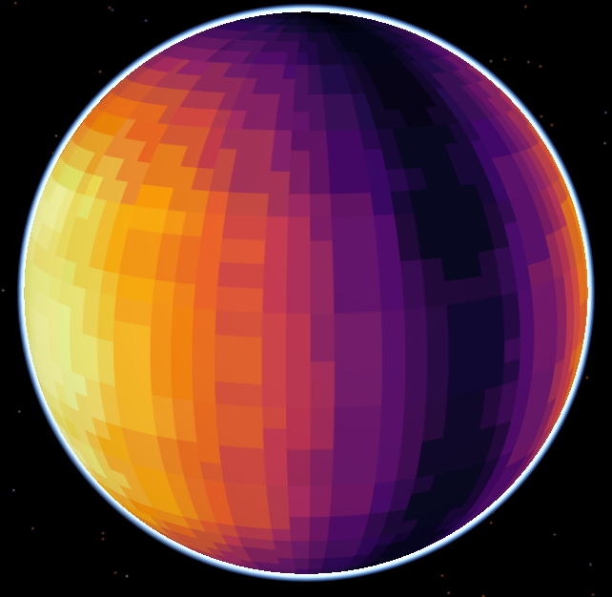
Figure 11 Sunshine map
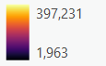
Figure 12 Interval of sunshine values
We can see that the sunshine is present at the equator centered on a certain meridian and then decreases circularly around it. This same pattern is present on the other side of the planet in a symmetrical way. The values range from 2 to 397 W/m² which is very similar to terrestrial values.
To normalize we want the interval from 0 to 100 to become 0 to 25 in the increasing direction. We want the interval from 300 to 400 to become 0 to 25 in the decreasing direction with 4000. 200 being the intermediate value, it will become 100 on the new interval. The further away from 200, the closer to 25 on the new interval with 100 and 300 25.
Then we have to recombine the 3 intervals and we obtain the final interval.
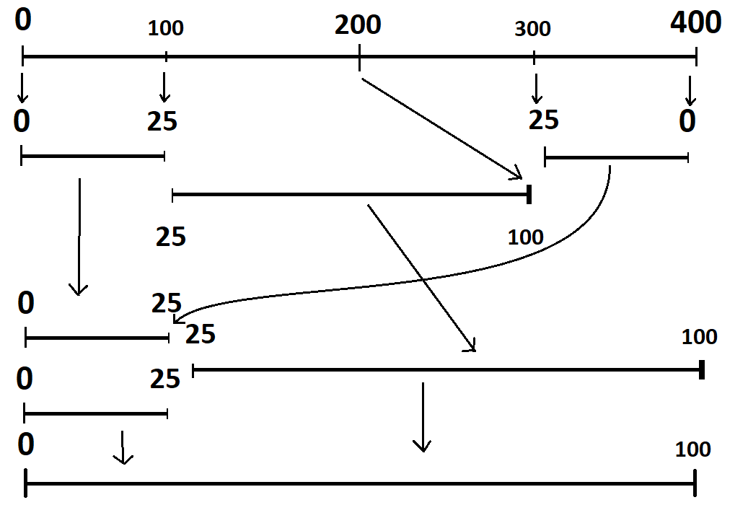
Figure 13 Explanation of normalization
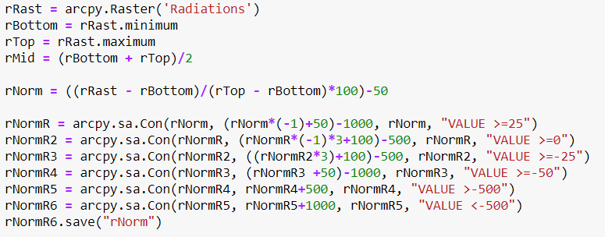
Figure 14 Code for sunlight
It was necessary to find a way to normalize as desired because it is not possible to check the value of a cell by performing an if test.
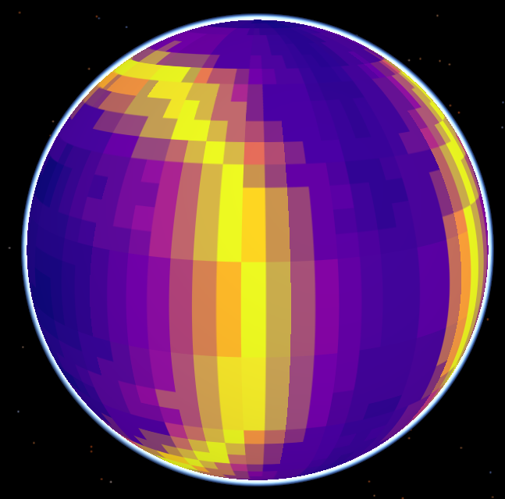
Figure 15 Sunshine map after normalization
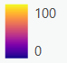
Figure 16 Intervals after normalization
We observe that the map forms a circle on the values closest to 100 and the code seems to have worked if we look at the map before normalization.

All that remains is to combine the three maps. We just have to get the coefficients requested from the user and apply them to the maps, then add them together, making sure that the sum of the coefficients is equal to 1.

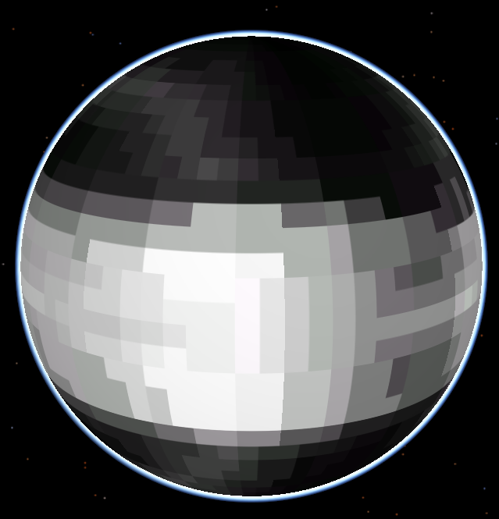
Figure 17 Final map
By choosing 0.5 for temperature, 0.3 for sunshine and 0.2 for precipitation.
Here is the final map with the white cells representing the area most suitable for habitation. To make it clearer we apply a filter that contrasts very strongly on the cells whose value is greater than 80.
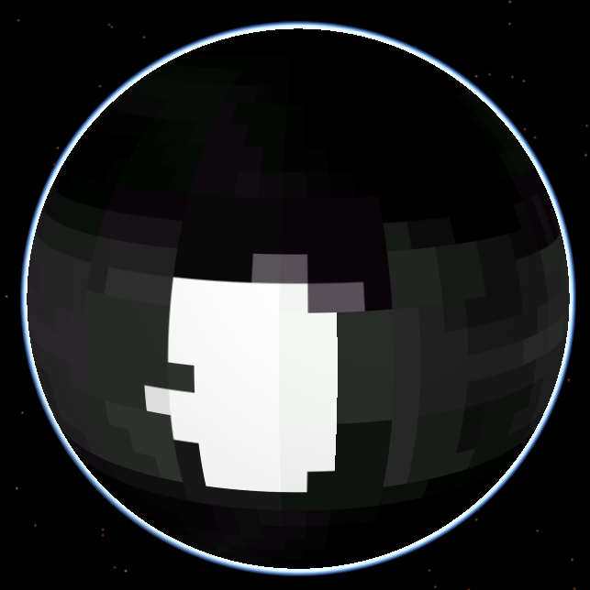
Figure 18 Final map with 80 filter
As the previous maps were symmetrical we get the same pattern on the other side of the planet. Happy colonizing!!!

